

Politecnico di Milano

A.A. 2015-2016

Software Engineering 2: “myTaxiService”

Requirements Analysis and Specifications

Document

Version 1.0

Milica Jovanovic (mat. 835953), Pavle Vidanovic (mat. 854472)

23 October 2015

Contents

1 Introduction 7

1.1 Purpose 7

1.2 Scope 7

1.3 Glossary 7

1.4 Reference Documents 8

1.5 Document Overview 8

2 Overall Description 9

2.1 Product perspective 9

2.2 Identifying stakeholders 9

2.3 User characteristics 9

2.4 Actors identifying 9

2.5 Goals 9

2.6 Domain properties 10

2.7 Constraints 10

2.8 Assumptions and Dependencies 11

2.9 Future possible implementation 12

3 Specific Requirements 12

3.1 External Interface Requirements 12

3.2 Functional Requirements 22

3.3 The world and the machine 24

3.4 Scenarios 25

3.5 UML Models 28

3.6 Non Functional Requirements 50

4 Appendix 52

4.1 Alloy 52

4.2 Software and tool used 63

4.3 Hours of works 64

5 Revision 64

5.1 Changed Assumptions 64

5.2 Removed goal and functionality 64

5.3 Modified Functional Requirements 64

5.4 Modified Scenarios and Use Cases 65

5.5 Modified Diagrams 66

* + 1. [G1] Allow a visitor to became a registered user and choose

|  |  |  |  |
| --- | --- | --- | --- |
|  |  | the public or private nature of his/her calendar. . . . . . | 22 |
|  | 3.2.2 | [G2] Allow user to log in to application. . . . . . . . . . . | 22 |
|  | 3.2.3 | [G3] Allow user to create a new event in the calendar and |  |
|  |  | choose the public or private nature. . . . . . . . . . . . . | 22 |
|  | 3.2.4 | [G4] Allow user to modify an existing event of his/her |  |
|  |  | calendar. . . . . . . . . . . . . . . . . . . . . . . . . . . . | 23 |
|  | 3.2.5 | [G5] Allow user to delete an existing event of his/her cal- |  |
|  |  | endar. . . . . . . . . . . . . . . . . . . . . . . . . . . . . . | 23 |
|  | 3.2.6 | [G6] Allow user to invite/delete other user to a specific |  |
|  |  | event of his/her calendar. . . . . . . . . . . . . . . . . . . | 23 |
|  | 3.2.7 | [G7] Allow user to see the weather forecast of a specific |  |
|  |  | event of his/her calendar. . . . . . . . . . . . . . . . . . . | 23 |
|  | 3.2.8 | [G8] Allow user to see the public event of other registered |  |
|  |  | user. . . . . . . . . . . . . . . . . . . . . . . . . . . . . . . | 24 |
|  | 3.2.9 | [G9] Allow user to see event to which has been invited. . . | 24 |
|  | 3.2.10 | [G10] After login, application will notify only the creator user three days before an event takes place if the weather |  |
|  |  | is not good. . . . . . . . . . . . . . . . . . . . . . . . . . . | 24 |
|  | 3.2.11 | [G11] After login, application will notify invited user one |  |
| days before an event takes place if the weather is not good. 24 | |
| 3.3 | The world and the machine . . . . . . . . . . . . . . . . . . . . . | | 25 |
| 3.4 | Scenarios . . . . . . . . . . . . . . . . . . . . . . . . . . . . . . . | | 26 |
|  | 3.4.1 Scenario 1 . . . . . . . . . . . . . . . . . . . . . . . . . . . | | 26 |
|  | 3.4.2 Scenario 2 . . . . . . . . . . . . . . . . . . . . . . . . . . . | | 26 |
|  | 3.4.3 Scenario 3 . . . . . . . . . . . . . . . . . . . . . . . . . . . | | 26 |
|  | 3.4.4 Scenario 4 . . . . . . . . . . . . . . . . . . . . . . . . . . . | | 27 |
|  | 3.4.5 Scenario 5 . . . . . . . . . . . . . . . . . . . . . . . . . . . | | 27 |
|  | 3.4.6 Scenario 6 . . . . . . . . . . . . . . . . . . . . . . . . . . . | | 27 |
|  | 3.4.7 Scenario 7 . . . . . . . . . . . . . . . . . . . . . . . . . . . | | 27 |
|  | 3.4.8 Scenario 8 . . . . . . . . . . . . . . . . . . . . . . . . . . . | | 28 |
| 3.5 | UML Models . . . . . . . . . . . . . . . . . . . . . . . . . . . . . | | 29 |
|  | 3.5.1 Use Case . . . . . . . . . . . . . . . . . . . . . . . . . . . | | 29 |
|  | 3.5.1.1 Vistiros registers to MetoCal . . . . . . . . . . . | | 29 |
|  | 3.5.1.2 login . . . . . . . . . . . . . . . . . . . . . . . . . | | 32 |
|  | 3.5.1.3 Create new event on calendar . . . . . . . . . . . | | 34 |
|  | 3.5.1.4 User modifies an event . . . . . . . . . . . . . . | | 36 |
|  | 3.5.1.5 User deletes an event from calander . . . . . . . | | 38 |
|  | 3.5.1.6 User invites other user to an event . . . . . . . . | | 40 |
|  | 3.5.1.7 Remove user from an event guest list . . . . . .  3.5.1.8 User modify the event date after application has notified him/her that there will be bad weather | | 42 |
|  | and suggest him/her the closest sunny day. . . . | | 44 |
|  | 3.5.1.9 User accept invitation . . . . . . . . . . . . . . .  3.5.1.10 User sees notification for modified event with an- | | 46 |
|  | other invitation . . . . . . . . . . . . . . . . . . | | 48 |

3.5.1.11 User sees details of an event . . . . . . . . . . . 50

* + 1. Class Diagrams . . . . . . . . . . . . . . . . . . . . . . . . 52
    2. State Machine Diagrams . . . . . . . . . . . . . . . . . . . 53

3.6 Non Functional Requirements . . . . . . . . . . . . . . . . . . . . 54

* + 1. Performance Requirements . . . . . . . . . . . . . . . . . 54
    2. Design Constraints . . . . . . . . . . . . . . . . . . . . . . 54
    3. Software System Attributes . . . . . . . . . . . . . . . . . 54
       1. Availability . . . . . . . . . . . . . . . . . . . . . 54
       2. Maintainability . . . . . . . . . . . . . . . . . . . 54
       3. Portability . . . . . . . . . . . . . . . . . . . . . 54

3.6.4 Security . . . . . . . . . . . . . . . . . . . . . . . . . . . . 54

* + - 1. External Interface Side . . . . . . . . . . . . . . 54
      2. Application Side . . . . . . . . . . . . . . . . . . 55
      3. Server Side . . . . . . . . . . . . . . . . . . . . . 55

1. Appendix 56
   1. Alloy . . . . . . . . . . . . . . . . . . . . . . . . . . . . . . . . . . 56
      1. Data Type . . . . . . . . . . . . . . . . . . . . . . . . . . 56
      2. Abstract Entity . . . . . . . . . . . . . . . . . . . . . . . . 57
      3. Abstrac Entity Implementation and Signature . . . . . . . 58
      4. Fact . . . . . . . . . . . . . . . . . . . . . . . . . . . . . . 60
      5. Assert . . . . . . . . . . . . . . . . . . . . . . . . . . . . . 61
      6. Predicates . . . . . . . . . . . . . . . . . . . . . . . . . . . 62
      7. Result . . . . . . . . . . . . . . . . . . . . . . . . . . . . . 63
      8. Generated world . . . . . . . . . . . . . . . . . . . . . . . 64
   2. Software and tool used . . . . . . . . . . . . . . . . . . . . . . . . 68
   3. Hours of works . . . . . . . . . . . . . . . . . . . . . . . . . . . . 68
2. Revision 68
   1. Changed Assumptions . . . . . . . . . . . . . . . . . . . . . . . . 68
   2. Removed goal and functionality . . . . . . . . . . . . . . . . . . . 69
   3. Modified Functional Requirements . . . . . . . . . . . . . . . . . 69
   4. Modified Scenarios and Use Cases . . . . . . . . . . . . . . . . . 70
   5. Modified Diagrams . . . . . . . . . . . . . . . . . . . . . . . . . . 70

# Introduction

## Purpose

The purpose of this document is to provide a comprehensive description of the myTaxiService system. It’s aim is to communicate what the software should do and identify the capabilities and characteristics of the system being developed, as well as the constraints it should respect. This document is meant for everyone included in the production of the software.

## Scope

The aim of this project is to develop and implement myTaxiService, an application similar to Uber, which makes the process of assigning an available taxi vehicle to possible passengers.

The developed system should allow new users to register. Users, once logged in, should be able to:

* request a taxi
* reserve a taxi
* cancel a ride
* check taxi availability around him
* receive a confirmation with information about the assigned vehicle and ETA once taxi is requested
* create/maintain user profile

The developed system should allow new taxi drivers to register. Drivers, once logged in, should be able to:

* inform the system about their availability
* confirm that they are going to take care of a certain call
* create/maintain taxi driver profile

The system should keep information about new arrived requests, as well as the confirmed rides. A ride should have and id number, information about the passenger that requested the ride, as well as the code of the assigned vehicle and ETA. System should also keep information about taxi queues connected to particular zone of the city and ensure fair management of the queues. Developed system should keep information about the list of reservations made by passengers, such as id number of the reservation, information about the passenger that made the reservation and the time of reservation and time of the ride.

## Glossary

The following are the definitions of some commonly used phrases throughout the document:

|  |  |
| --- | --- |
| *ETA* | Estimated Time of Arrival, approximated time of arrival of taxi vehicle to destination |
| *Reservation* | Passenger request for a vehicle at least 2 hours before the ride |
| *Request* | Passenger filled form for immediate ride |
| *Reservation* *Conformation* | Notification sent to the user about the confirmed reservation |
| *Ride Conformation* | Notification sent to the user about the confirmed ride with information of the ride |
| *User* | A person already registered and logged into the system |
| *Guest* | A person accessing a system that has either never registered or hasn't logged in yet. Guest has only two available options, to log in or to register for the first time |
| *Taxi* *driver* | A person already register and logged into the system as a driver |
| *Developer* | ???? A person who can add additional functionalities to the system |
| *GPS* | Global Positioning System |
| *API* | *:* Application Programming Interface*.* |

Podsetnik

Acronyms

* RASD: Requirements Analysis and Specification Document.
* DB: DataBase.
* DBMS: DataBase management system.
* Database Management System ( DBMS ).
* OS: Operating System.

## Reference Documents

* IEEE Std 830-1998 Recommender Practice for Software Requirements Specifications
* Specification Document: myTaxiService Project AA 2015-2016.pdf

## Document Overview

The document is essentially structured in four parts:

* Chapter 1: Introduction, gives description of document and some basic information about the software
* Chapter 2: Overall Description, gives an overview of the main functionalities of the software to be with constraints, as well as the hardware limitations.
* Chapter 3: Specific Requirements, body of the document that describes in more detail functionalities, possible scenarios and use cases.
* Chapter 4: Appendices, Alloy simulation of the previous UML diagrams.

# Overall Description

## Product perspective

*myTaxiService* is mobile web application that provides user with services described in section 1.2. System will consist of two applications and server between them. The software will be developed using a client-server model. The server side contains the application logic and is used to interact with permanent storage, serve pages to the client and process user input. The web client consists of dynamic web pages which provides user friendly graphical interface and the web browser through which they are accessed. Considering *myTaxyService* is a mobile web application, it is platform independent. The only requirement is users having a web browser installed on a device of their choice.

## Identifying stakeholders

There are two distinct interest groups of people regarding this project:

* *Company* that provided project specification and expect it to be delivered in a way that satisfies given specification while respecting the set deadline and budget
* *Developer group,* in this case group of two people
* *Taxi driver,* person working for the company that ordered the software product

Passenger ???

## User characteristics

myTaxiService is expected to have users across a wide range of demographics, meaning users of any age, gender and educational background. Still, given of the ubiquitous nature of internet and social media, it is assumed that people using our software do have the basic web browsing skills.

## Actors identifying

Three possible actors interacting with our system are the following:

* *Guest* person accessing a system that has either never registered of hasn't logged in yet. Guest can only access the initial page from where he has only two available options, to log in or to sign up for the first time
* *User* a person already registered and logged into the system. User can use all of the features offered by the passenger application
* *Taxi**driver*a person already registered and logged into the system. User can use all of the features offered by the taxi driver application
* Developer ???

## Goals

Having possible users in mind, myTaxyService should have these features:

* [G1] registering new user
* [G2] managing user's profile
* [G3] requesting a taxi
* [G4] reserving a taxi
* [G5] canceling a ride
* [G6] checking taxi availability around user
* [G7] receiving notifications about the reservation or request confirmation
* [G8] confirming/declining a ride(taxi driver) – maybe splitting to two UseCases
* [G9] developing additional services ???

## Domain properties

It is supposed that these conditions hold in the analyzed world:

* the passenger needs a ride to specific location
* the details of the ride provided by the passenger are accurate
* money exchange between the passenger and the taxi driver is made independently from the myTaxiService system
* distinction between the zones are clearly defined

## Constraints

### 2.7.1 Regulatory policies

myTaxiService application will not take advantage of users personal information and will respect the privacy policy. User will be notified about it.

### 2.7.2 Hardware limitation

User must have access to Internet and own a device with a web browser and GPS service.

### 2.7.3 Interfaces to other applications

myTaxiService application is integrated with Google Maps API to access their maps and email service in order to make authentication.

### 2.7.4 Parallel operation

myTaxiService will support parallel access to the applications database in a transparent way.

## Assumptions

Considering that there were some ambiguities in the specification document, the following facts are assumed:

* users register with their email, password, name, surname and phone number
* users can change their email and password
* user have only one account
* user provides accurate information
* if users location is not available, the application will show a screen with a message of service unavailability
* there is a Terms & Conditions section to indicate clearly the usage of the application, which if not followed will result in account deactivation
* we assume that Google Maps service will calculate location used by myTaxiService accurately
* we assume that taxi driver will respect the ETA, otherwise they could be banned from the system
* if a taxi driver has an unexpected issue, the user will be automatically notified by the system and a new vehicle will be assigned to him with new ETA

## Future possible implementation

* + - another way of payment will be added as an options for users to pay online
    - an option for users to rate the drivers
    - Facebook authentication could be added as a way of registering
    - application could be updated so it works more efficiently
    - taxi sharing options could be added to the system

# Specific Requirements

## External Interface Requirements

### 3.1.1 User Interfaces

In this section mockups of myTaxiService application will be enclosed which will mimic the general idea of the software system:

In figure 1. Initial page is showed, which offers two possibilities to the guest user. Guest user could create an account if he does not own one or he could sign in with his credentials.

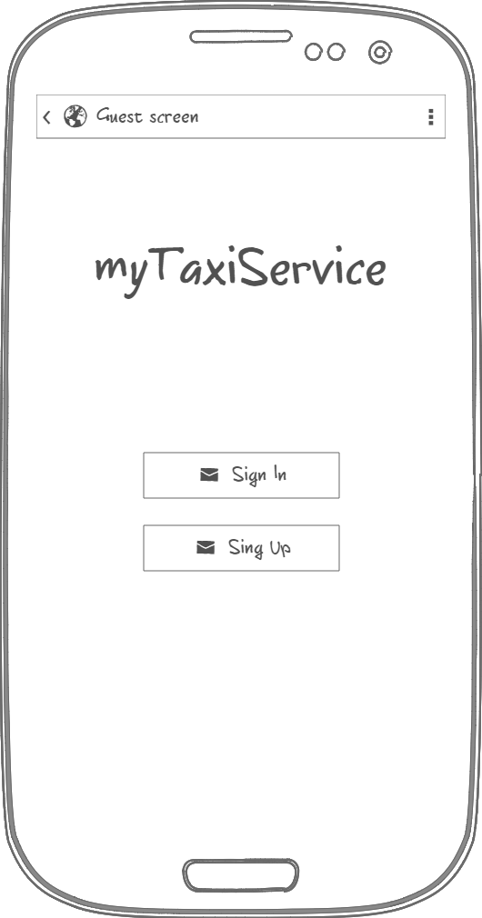

Figure 1.

In figure 2. Initial page is showed, which offers two possibilities to the guest user. Guest user could create an account if he does not own one or he could sign in with his credentials.

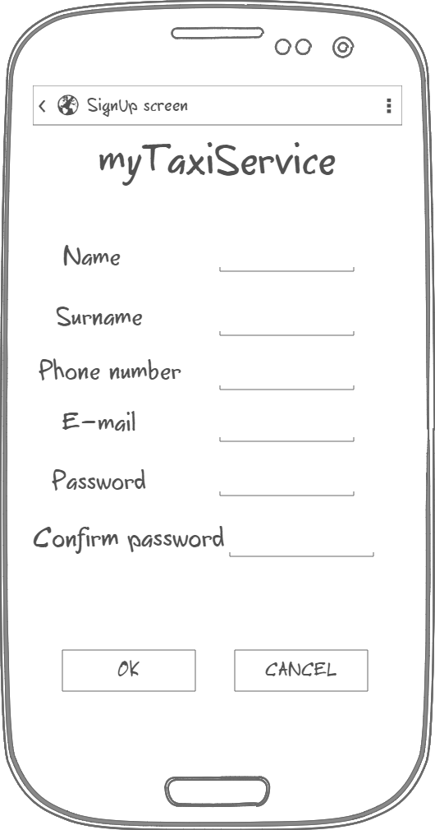

3.1.1.3 Home page This mockup shows the home page of an hipotetic user Ettore. The circles rapresent events, the colours if they are private or public, or both (only if in specific date I have at least two events, one private and the other public, for example on friday the 5 th.

3.1.1.4 Click pop-up This mock up shows what happens when a user clicks on a blank date. A pop-up message will ask to the user if he/she wants to create a new event.

3.1.1.5 Event creation This mock up shows the event creation form.

3.1.1.6 Click event created This mock up shows what happens when the user clicks on an event he created (event represented by a colored circle). A pop-up will show some informat and give some functionality options.

3.1.1.7 More detail on event This mock up shows what user sees when he click on “more details”.

3.1.1.8 Alert This mock up shows examples of pop-up alert.

3.1.2 API interfaces

For the weather forecast part of the MeteoCal application we use the OpenWeatherMap API. As well described on the website this API give access to current weather data for any location on Earth including over 200,000 cities. Current weather is frequently updated basing on global models and data from more than 40,000 weather stations. Also Data is available in JSON, XML, or HTML format. For the forecast information indeed both 5 day forecasts and 16 day forecasts are available at any location or city. 5 day forecasts include weather data every 3 hours and 16 day forecasts include daily weather. For more information see the OpenWeatherMap website[(http://openweathermap.org/api)](http://openweathermap.org/api).

3.1.3 Hardware Interfaces

This project does not support any hardware interfaces.

3.1.4 Software Interfaces

* Database Management System ( DBMS ):
  + Name: MySQL.
  + Version: 5.6.21
  + Source: <http://www.mysql.it/>
* Java Virtual Machine ( JVM ).
  + Name: JEE
  + Version: 7
  + Source: <http://www.oracle.com/technetwork/java/javaee/tech/index.html>
* Application server:
  + Name: Glassfish.
  + Version: 4.1.
  + Source: <https://glassfish.java.net/>
* Operating System ( OS ).
  + Application must be able to run on any SO which supports JVM and DBMS specified before.
    1. Communication Interfaces

|  |  |  |
| --- | --- | --- |
| Protocol | Application | Port |
| TCP | HTTPS | 443 |
| TCP | HTTP | 80 |
| TCP | DBMS | 3306 ( default ) |

* + 1. Memory

The minimum memory requirements are:

* Primary Memory: 2 GB +
* Secondary Memory: 32 GB +

## Functional Requirements

3.2.1 [G1] Allow a visitor to became a registered user and choose the public or private nature of his/her calendar.

* [R1] Visitor must not be already registred to perform registration process.
* [R2] Visitor must choose a username not already used by another user.
* [R3] User can not sign up twice but only once for session.
* [R4] Visitor can just see login page.
* [R5] Visitor can only access to registration form.
* [D1] Email address used for registration must be formally correct.

3.2.2 [G2] Allow user to log in to application.

* [R1] User must be already regitred to success login process.
* [R2] User must know his username and password used during registration to success login.
* [R3] Username and password insert during login process must be correct.
* [R4] Wrong credentials will not grant access to user to the calendar.
* [R5] Visitor can’t access to calendar page before registration.
* [R6] Application will not implement retrive password mechanism.

3.2.3 [G3] Allow user to create a new event in the calendar and choose the public or private nature.

* [R1] User must be already registred and logged in the application.
* [R2] User must complete event creation form and confirm the creation.
* [R3] User must complete mandatory fields to complete the event creation process.
* [D1] Time must be included between 00.00 and 23.59.

3.2.4 [G4] Allow user to modify an existing event of his/her calendar.

* [R1] User must be already registred and logged in the application.
* [R2] The event user wants to modify must have been already created and saved.
* [R3] User must confirm updating process.
* [R4] Updating process is not reversible, modified data will be lost.

3.2.5 [G5] Allow user to delete an existing event of his/her calendar.

* [R1] User must be already registred and logged in the application.
* [R2] User must be the owner of the event he wants to delete.
* [R3] User must confirm deleting process.
* [R4] Deleting process is not reversible, all event data will be lost.

3.2.6 [G6] Allow user to invite/delete other user to a specific event of his/her calendar.

* [R1] User must be already registred and logged in the application.
* [R2] User must be the owner of the event to invite or delete other users.
* [R3] User can not invite or delete itself.
* [R4] User can only invite registered users who have not been already invited.
* [R5] To invite a user, the owner of the event, must know email or name or surname or part of them of that specific user. A search bar is implemented to recognise the correct user to invite.
* [R6] User can not delete registered users who have been already deleted.
* [R7] User that have been delete from an event can be invited again.

3.2.7 [G7] Allow user to see the weather forecast of a specific event of his/her calendar.

* [R1] User must be already registred and logged in the application.
* [R2] User can see weather forecast information of a specific event only if they are allowed by visibility property.
* [D1] Weather forecast of a specific event can be seen only if it was available during creation process or scheduled updating.

3.2.8 [G8] Allow user to see the public event of other registered user.

* [R1] User must be already registred and logged in the application.
* [R2] Event must exist and be public.

3.2.9 [G9] Allow user to see event to which has been invited.

* [R1] User must be already registred and logged in the application.
* [R2] Event must exist, owner of the event has correctly created it.
* [R3] User must have been invited to the event from the owner.

3.2.10 [G10] After login, application will notify only the creator user three days before an event takes place if the weather is not good.

* [R1] User must be already registred and logged in the application.
* [R2] Event must exist, owner of the event has correctly created it.
* [R3] Application will notify the owner of the event only when he/she performs login.
* [R4] Notification will propouse to its creator the closest sunny day if available.

3.2.11 [G11] After login, application will notify invited user one days before an event takes place if the weather is not good.

* [R1] User must be already registred and logged in the application.
* [R2] Event must exists, owner of the event has correctly created it.
* [R3] Application will notify invited users of the event only when they perform login.

## The world and the machine

For a first domain analysis of MeteoCal application we use “The World & Macchine” model by M. Jackson & P. Zave. This approach let us identify the entities inside the domain that interact with the application (“The World”), entities to be developed (“The Machine”) and the intersection (“Shared Phenomena”) between the world and the application, that are all world informations known or managed direclty by the application.

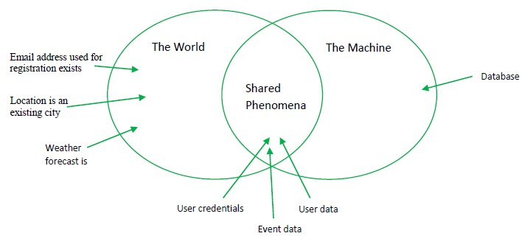

## Scenarios

3.4.1 Scenario 1

Ottaviano’s birthdays is in five days, he has already booked a room in “mega super awesome”, the most exclusive local in his home town. Ottaviano wants to invite to his party ten of his closest friends, but not Turing. Everyone hates Turing, he is so petulant and arrogant. Ottaviano and his closest friends are already registred users of MeteoCal so he log in to application and starts the event creation process. Otaviano compliles all mandatory fields and carefully set the event as private, and finally invites his ten friends. Now they can easily keep in mind the party’s date and Turing will never know he has been excluded, because event has been set has private and he can not see event’s details.

3.4.2 Scenario 2

Dante wants to drop a big party somewhere hot. Dante log in to MeteoCal application, starts the event creation process and fills the “loction” field with “Hell”. When he tries to end the event creation process and click on “confirm”, the event is correctly created and saved in the database. Dante checks the weather forecast information and sees that is not available, but notices that “Hell” actually is not a valid location. He clicks on the “modify event” button and changes Hell with Palermo and saves. The event is updated with a valid location and meteo is now available.

3.4.3 Scenario 3

Leopardi wants to invite his beloved Silvia to a pic-nic in country side for declaring his love. He had check weather forecast in a meteorologic site and knows that next week there will be sunny days. Leopardi logs in into MeteoCal and starts creating event process. Leopardi imputs are valid and event is created for the 20th of july. He invites Silvia and one day later she accept the invitation. Days passes and unfortunaly the meteo forecast wasn’t so accurate and meteo has change, probably it will rain. Is the 17th of july and Leopardi logs in into MeteoCal and sees a notification that informs him of bad weather prevision. The application suggest to change the date of the event to 25th of july. Leopardi decides to change the date in which the event is scheduled and set the date suggested by the application. On 19th of july Silvia logs in into MeteoCal to check if she has any new notification and sees the one about the invitation of Leopardi’s event. Unfortunally she has a visit to the doctor the same date and decline the invitation. On 23th of july Leopardi logs in to MeteoCal and checks the informations of his event with Silvia and sees that he is the only participant and understands that Silvia has declined the invitation. With brocken heart Leopardi delete the event and decides to never leave his room again and dedicate his life to poetry.

3.4.4 Scenario 4

Randy is an athlete and wants to challenge Cena in a race to prove once for all who is the best. Randy logs in into MeteoCal and create a new event for the 9 of july. Soon after the creation of the event has been confirmed, the application alerts Randy that due to some technical problems the meteo forecast is not available at the moment, and it will be given as soon as possible. Randy decides to not change the date of the event but to wait for meteo forecast to be updated. Next day Randys checks his calendar and sees that weather forecast has been update and ther will be a sunny and warm day. He proceeds to invite Cena that immediately accepts. The day of the race comes and Randy wins.

3.4.5 Scenario 5

MeteoCal has been suggested to Attila as a valid application for scheduling events with meteo forecast informations. Attila wants to give a try to this new application and decides to start the regisration process. He chose “flagello” as username and then fill all the other mandatory fields. When he clicks the “confrim” button the registration process fails and the application alerts him that “flagello” is already used as username by another user, and he has to choose another username. Attila restarts registration process and this time writes “latinlover” in username field, then he clicks the “confirm” button. Registration process ends correctly and the new profile is created. Application notifies Attila that he successfully registrated to MeteoCal, and starting from now he can enjoy all the features.

3.4.6 Scenario 6

Bruce is very popular, has lots of friends and every weekend host a big party in his mansion. He makes all guests pay ten euros at the entry of the party and does not issues any recepit. Bruce is using MeteoCal for creating events and inviting people, and there are been no problems so far, then for the 23th of july he creates his 34th event of the year and invites three undred users. Bruce starts building a fortune and calls the attention of the “guardia di finanza” that starts to investigate on the 21th of july. Bruce decides that time to stop has come and to avoid any problem with the law he deletes his account of MeteoCal. Unfortunately MeteoCal dosn’t provide this features so Bruce’s account can not be deleted. When “guardia di finanza” asks for information about Bruce, MeteoCal developers are happy to collaborate with justice. Bruce will be captured and will spend the next 10 years in prison hoping in clemency of the President of the Republic.

3.4.7 Scenario 7

Zlatan is an outgoing guy and wants to let his friends know all the event in which he will partecipate so he set his calendar as public. Silvia falls in love with Zlatan and starts cheking daily his calendar to find where he would be, so that she can try to catch up with him. It has been almost a month since when Silvia has start chasing Zlatan that really does not appreciate her attention. Silvia is impolite and arrogant. He is fed up with this situation and can not take it anymore. Zlatan thinks of the easiest way to avoid Silvia and decides to change visibility policy of his calendar and turn it private. Unfortunately MeteoCal dosn’t provide this features. Next day Silvia logs into MeteoCal and continue to see all Zlatan events. Silvia continuos to follow Zlatan everywhere he goes. Zlatan start to appreciate her attention and efforts and suddendly, out of nowhere, fall in love with her and they lived happily ever after.

3.4.8 Scenario 8

Dante and Virgilio are best friends and spend most of the time togheter, they would follow each other even in hell. Next monday it will be Dante’s birthday and he is organizing a party so logs in into MeteoCal and creates a new event, then invites some friends and of course his best friend Virgilio. Four days before the birthday party, Dante and Virgilio have a big fight for silly reasons and now they are mad with each other. Dante decides that he does not want Virgilio to be at his party anymore and delete Virgilio invitation. One day before the birthday party Dante meets Virgilio, they explain themself and make it up. Dante changes his mind one last time, logs in into MeteoCal and invites again Virgilio to his party.

## UML Models

3.5.1 Use Case

3.5.1.1 Vistiros registers to MetoCal .

|  |  |
| --- | --- |
| Actor | Visitor |
| Goal | [ G 1] |
| Imput Condition | NULL |
| Event Flow | 1. Visitors on the home page clicks on “register”. button to start the registration process. 2. Visitor fills in at least all mandatory fields. 3. Visitors clicks on “confirm” button. 4. The application will save the date in the DB. |
| Otput Condition | Visitor succesfully ends registration process and become a User. From now on he/she can log in to the application using his/her credential and start using MeteoCal. |
| Exception | 1. The visitor is already a user. 2. One or more mandatory fields are not valid. 3. Username choosen is already used by another user. 4. Email choosen is already associated to another user.   All exception are handle alerting the visitor of the problem and application goes back to point 2 of EventFlow |

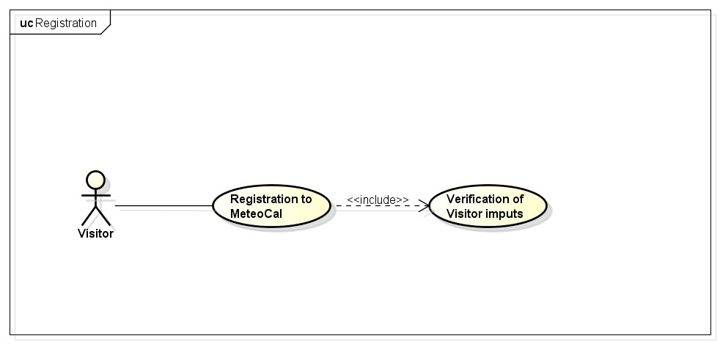

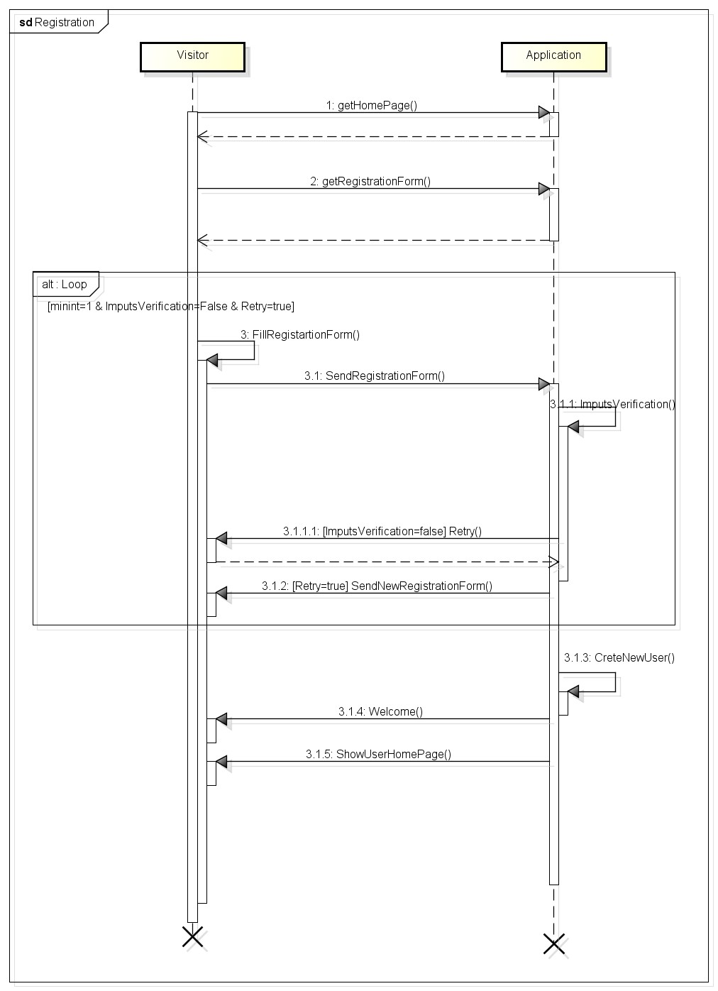

3.5.1.2 login .

|  |  |
| --- | --- |
| Actor | Visitor, Registered User |
| Goal | [ G 3] |
| Imput Condition | Visitor is registered into the system. |
| Event Flow | 1. MeteoCal show the login page. 2. Visitor complete the form inserting correct username and password. |
| Otput Condition | 1. MeteoCal verify the credential of visitor and if correct show the main page with calendar. 2. Visitor are promote to a registered user. |
| Exception | If username and/or password are incorrect MeteoCal notify that to visitor and show the login page. |

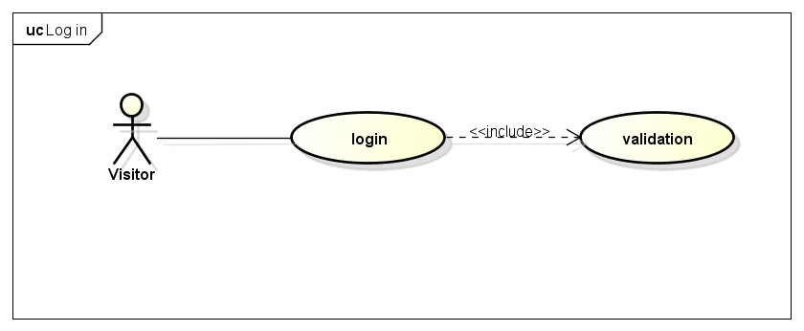

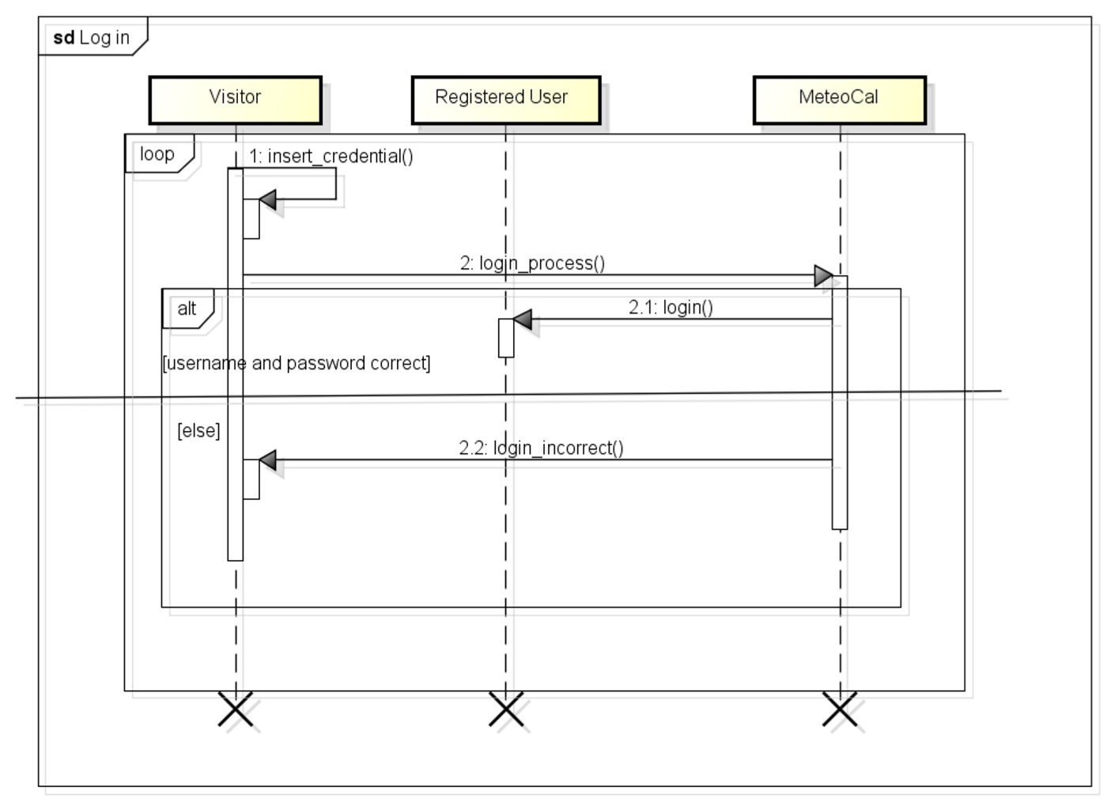

3.5.1.3 Create new event on calendar .

|  |  |
| --- | --- |
| Actor | Registered User |
| Goal | [ G 5] |
| Imput Condition | Registered User is already logged in into MeteoCal. |
| Event Flow | 1. Registered User click on a day of calendar. 2. Next click on “create event” and start the creating process. 3. MeteoCal show a new page with form. User complete form. |
| Output Condition | MeteoCal show the calendar main page with the new event. |
| Exception | User want to cancel the creating process. A cancel button is aviable. |

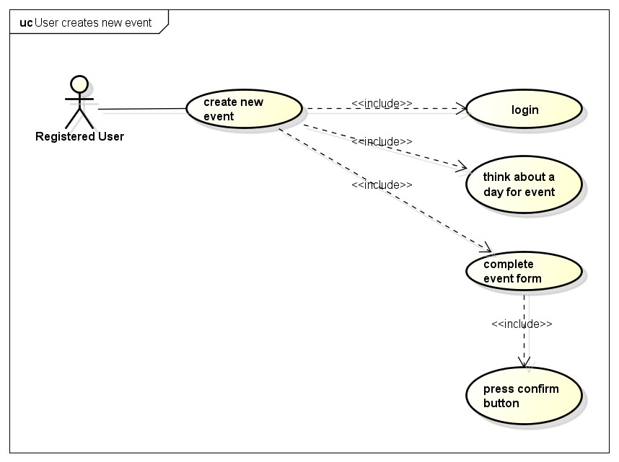

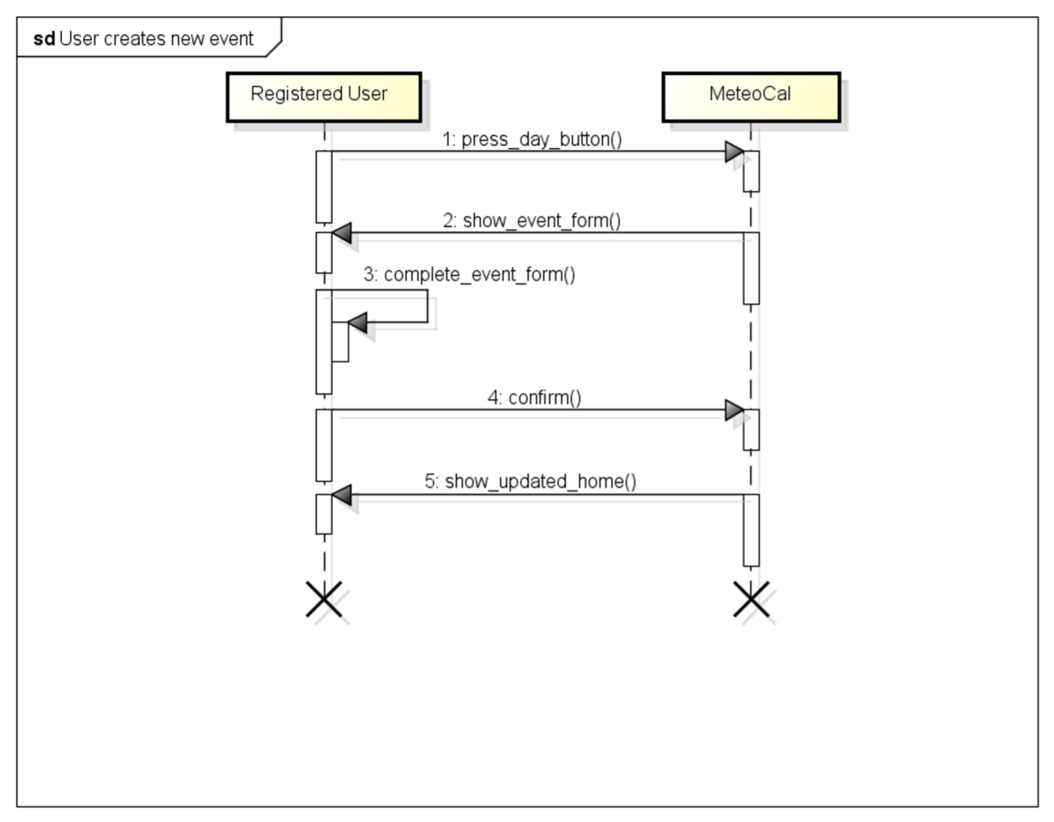

3.5.1.4 User modifies an event .

|  |  |
| --- | --- |
| Actor | Registered User. |
| Goal | [ G 6] |
| Imput Condition | Registered User is already logged in into MeteoCal. |
| Event Flow | 1. Registered User push on an existing event of calendar. 2. Next to “modify event” and start the modifyng process. 3. MeteoCal show a new page with form filled with existing information of event. 4. User modify form. |
| Output Condition | MeteoCal show the calendar main page with the modified event updated. |
| Exception | User want to cancel the modifyng process. A cancel button is aviable. |

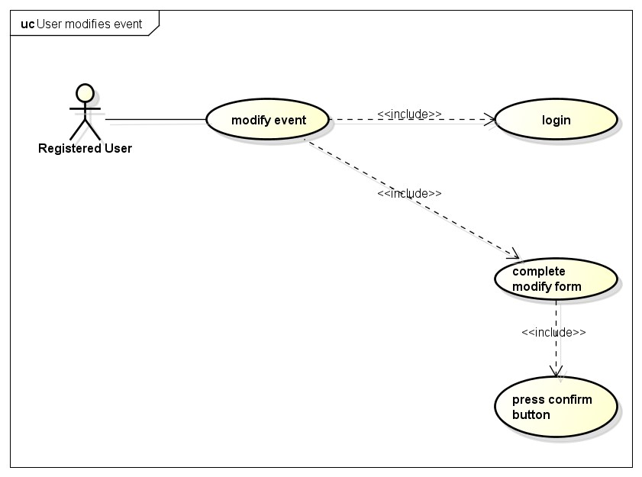

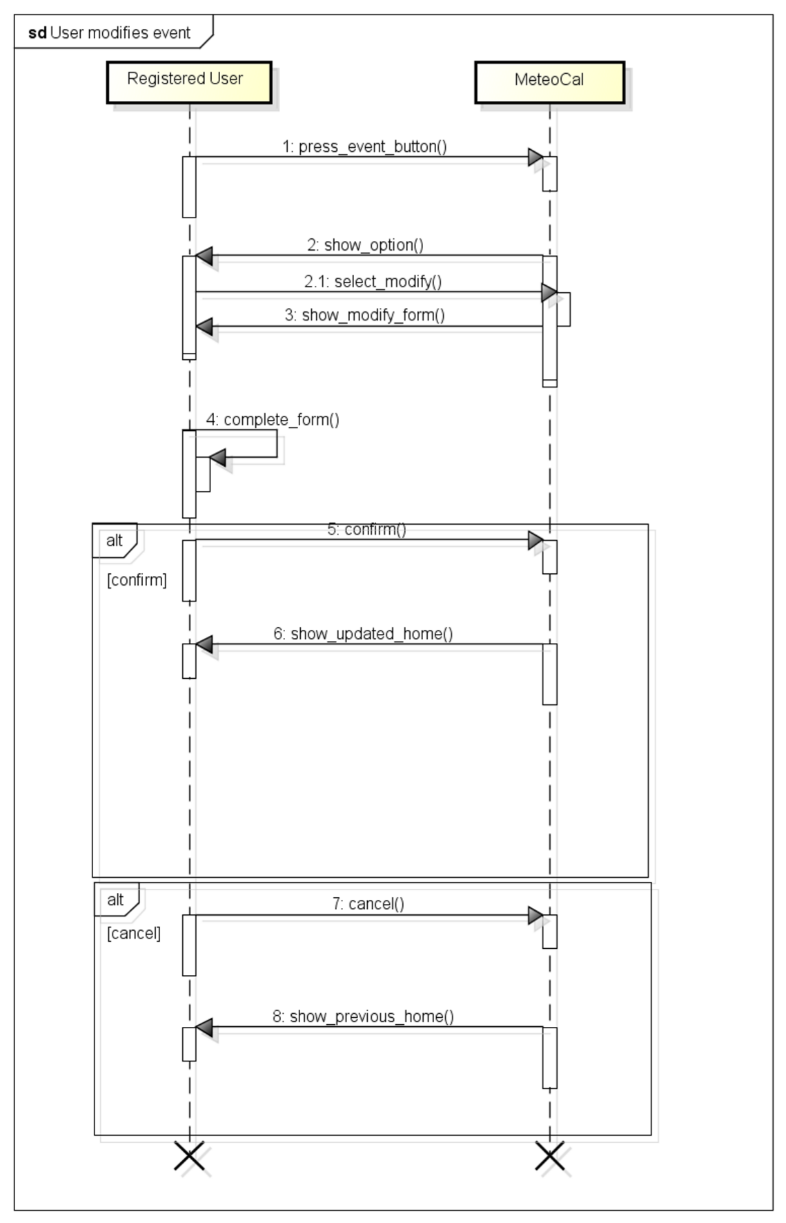

3.5.1.5 User deletes an event from calander .

|  |  |
| --- | --- |
| Actor | Registered User. |
| Goal | [ G 7] |
| Imput Condition | Registered User is already logged in into MeteoCal. |
| Event Flow | 1. Registered User push on an existing event of calendar. 2. Next on “delete event”. |
| Output Condition | MeteoCal show the calendar main page without the event that user choose to delete. |
| Exception | NULL |

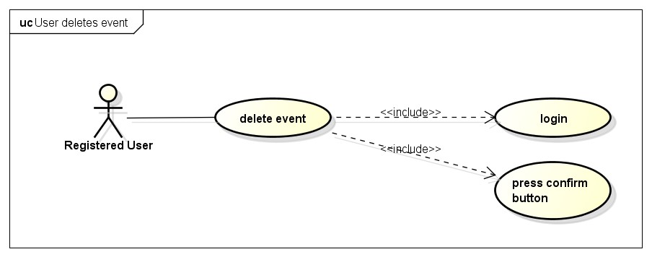

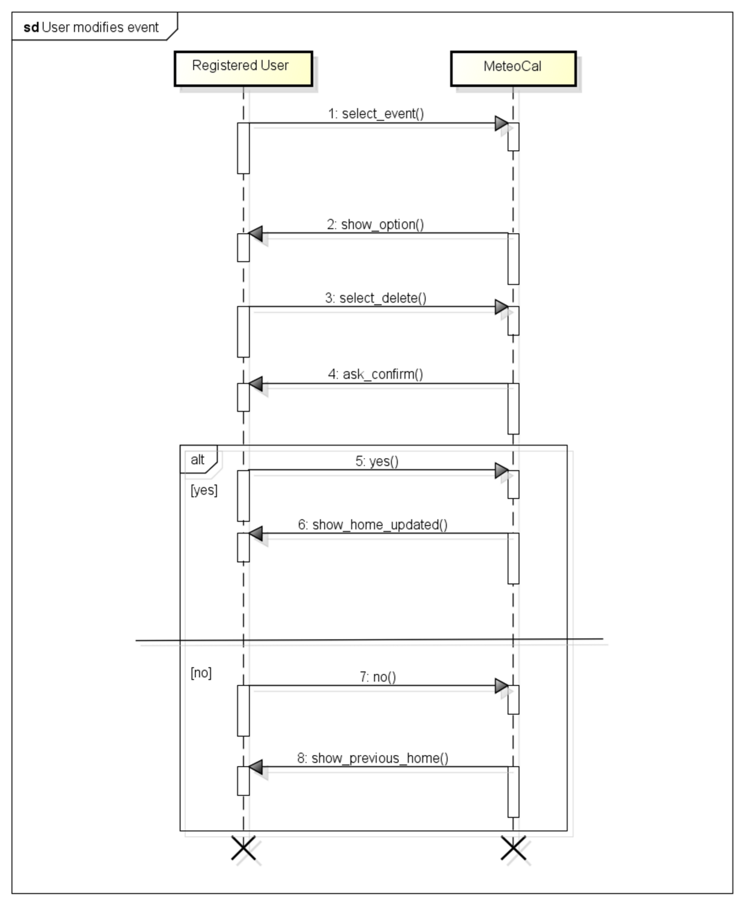

3.5.1.6 User invites other user to an event .

|  |  |  |
| --- | --- | --- |
| Actor | User |  |
| Goal | [ G 8] |  |
| Imput Condition |  |  |
|  | 1. | User must be registred. |
|  | 2. | User must be logged in into application. |
|  | 3. | User is in the calendar home page. |
| Event Flow |  |  |
|  | 1. | User clicks on the event colored circle. |
|  | 2. | User clicks on “invite” button. |
|  | 3. | User searchs for users who wants to invite. |
|  | 4. | User confirm invitation. |
| Output Condition | The invited user receive an invitation alert. | |
| Exception | 1. Appllication was not able to invite the user due to some internal issues.  All exception are handle alerting the user of the problem and application goes back to calendar home page. | |

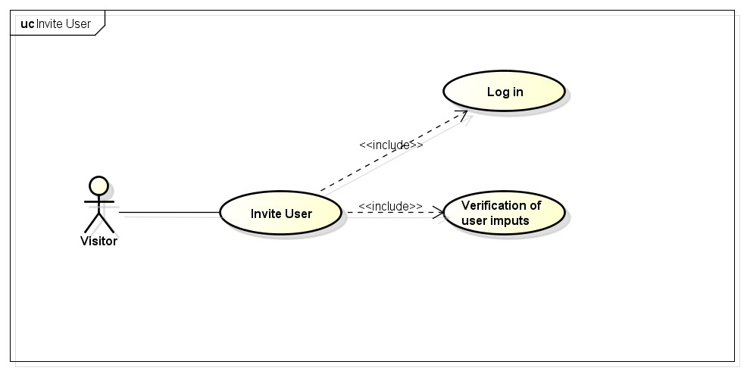

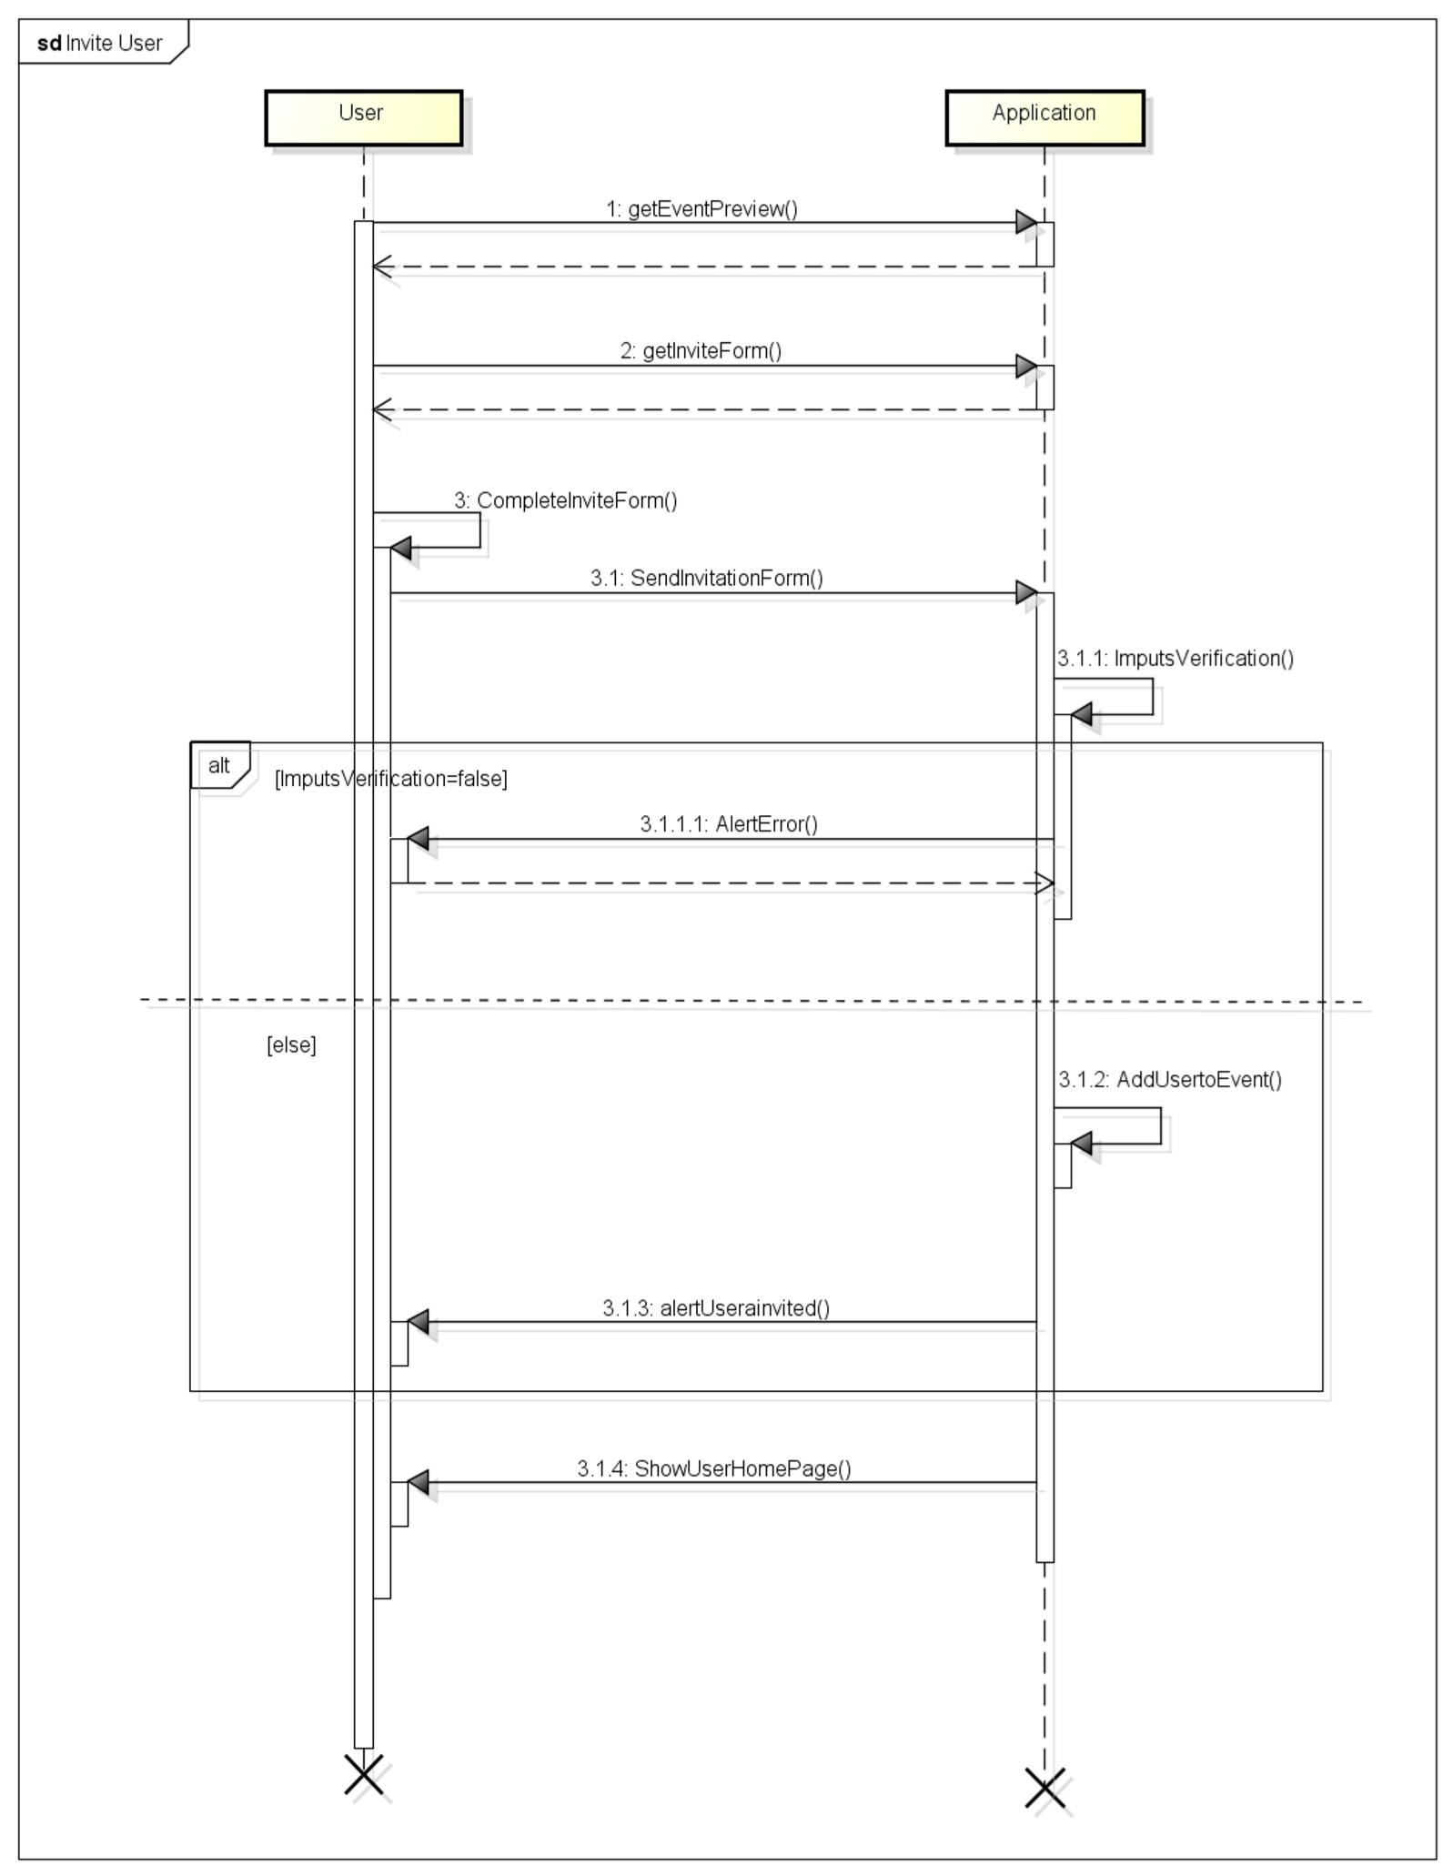

3.5.1.7 Remove user from an event guest list .

|  |  |  |
| --- | --- | --- |
| Actor | User |  |
| Goal | [ G 8] |  |
| Imput Condition |  |  |
|  | 1. | User must be registred. |
|  | 2. | User must be logged in into application. |
|  | 3. | User is in the modify event page. |
| Event Flow |  |  |
|  | 1. | User “uncheck”the usernames of the users he/she wants to remove from the guest list. |
|  | 2. | User confirms. |
| Output Condition | Users that have been unchecked are removed from the guest list and the event is updated. | |
| Exception | 1. Appllication was not able to complete remove operation the due to some internal issues.  All exception are handle alerting the user of the problem and application goes back to calendar home page. | |

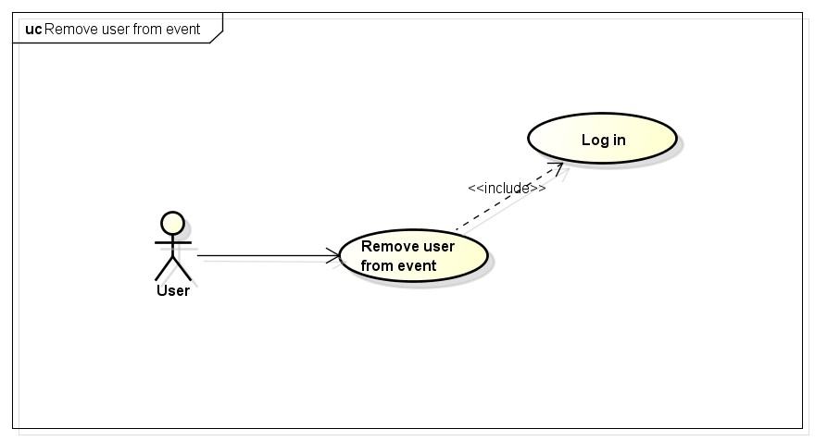

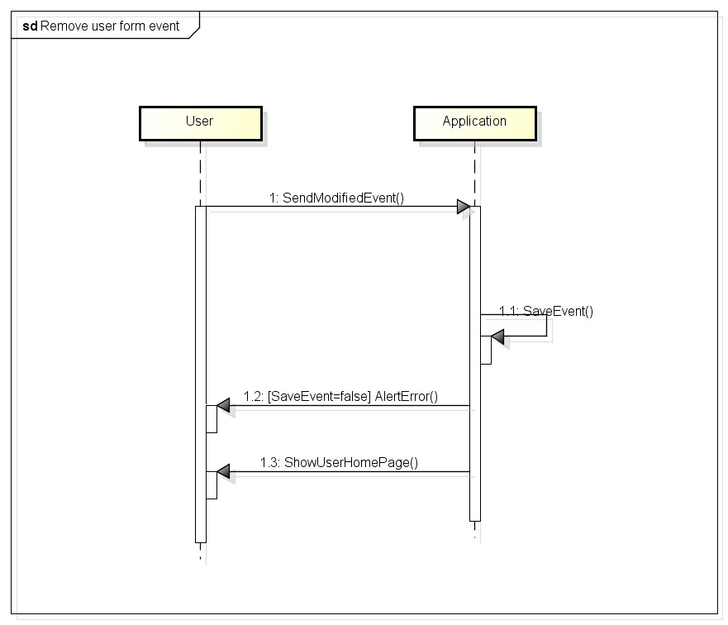

3.5.1.8 User modify the event date after application has notified him/her that there will be bad weather and suggest him/her the closest sunny day. .

|  |  |
| --- | --- |
| Actor | User |
| Goal | Modify an event date thanks to the suggestion of the application |
| Imput Condition | 1. User must be registred. 2. User must be logged in into application. |
| Event Flow | 1. Application notifies three days before the event will take place that there will be weather. 2. Application suggest the closest sunny day. 3. User accepts to modify the event date. |
| Output Condition | Event has been modified. |
| Exception | 1. One or more mandatory fields are not valid. 2. Appllication was not able to complete event update operation due to some internal issues.   All exception are handle alerting the user of the problem and application goes back to point 3 of Event Flow |

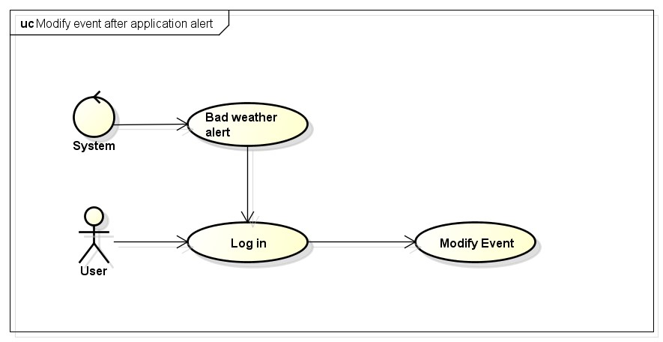

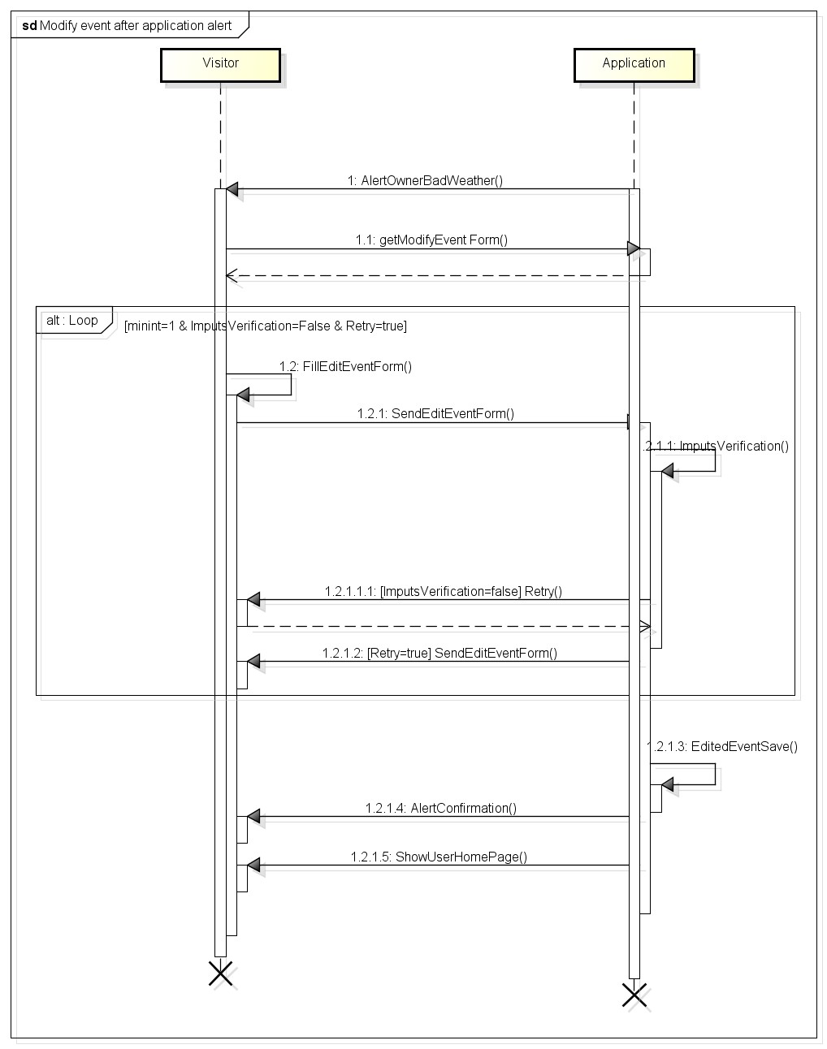

3.5.1.9 User accept invitation .

|  |  |
| --- | --- |
| Actor | User |
| Goal | User accept an invitation for an event he/she has been invited. |
| Imput Condition | 1. User must be registred. 2. User must be logged in into application. |
| Event Flow | 1. Application notifies the user the he/she has been invited to an event and asks to accept. 2. User accepts the invitation for the event. |
| Output Condition | User is now a guest of the event, he/she can see the event in their calendar home page. |
| Exception | 1. Appllication was not able to complete event update operation due to some internal issues.  All exception are handle alerting the user of the problem and application goes back to user’s calendar home page. |

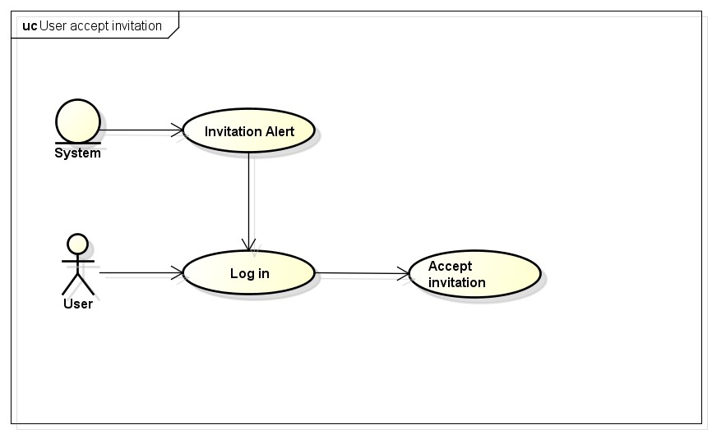

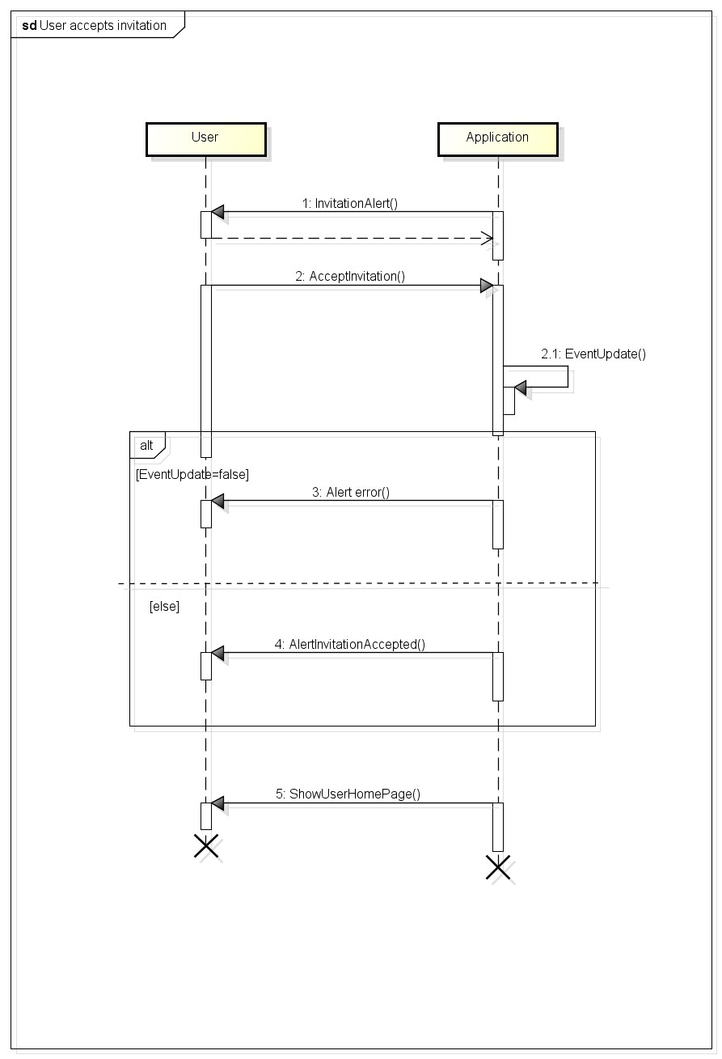

3.5.1.10 User sees notification for modified event with another invitation .

|  |  |
| --- | --- |
| Actor | Registered Users |
| Goal | User sees notification for modified event with another invitation. |
| Imput Condition | Registered Users log in into MeteoCal. |
| Event Flow | 1. MeteoCal show a notification to user who have been invited to an event when the event is modified by the owner asking for a new confirm. 2. User press “ok” button to notify. |
| Output Condition | MeteoCal show the main calendar page. |
| Exception | NULL |

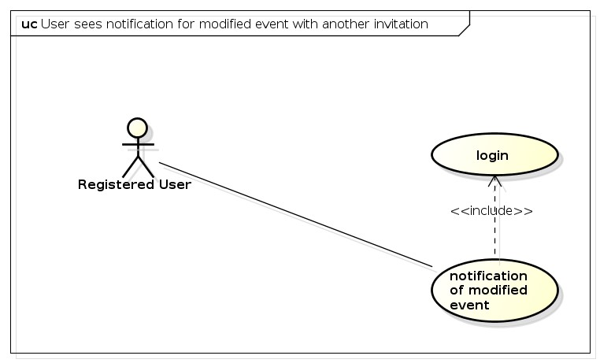

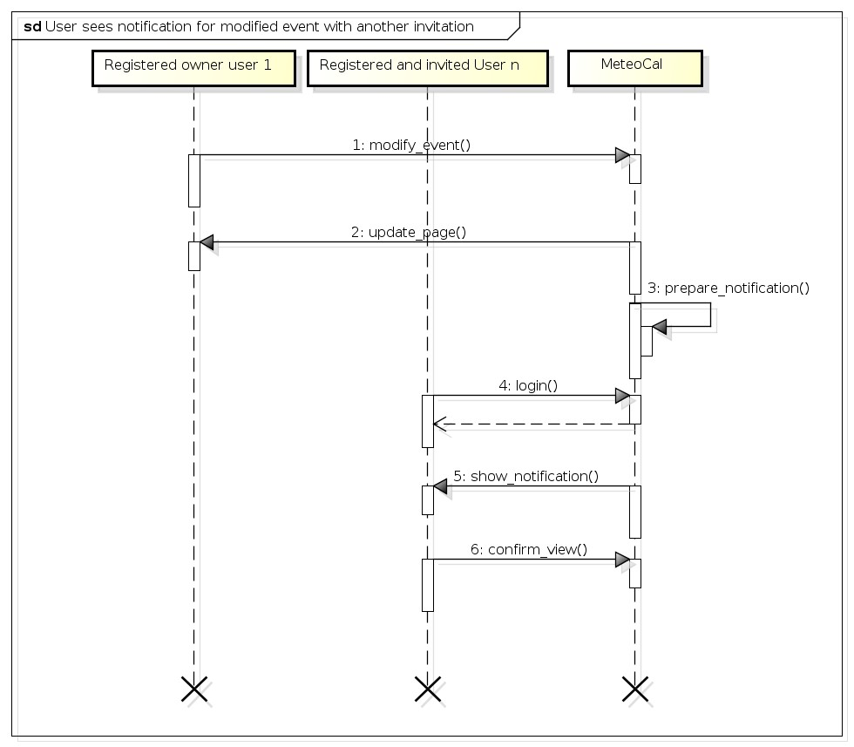

3.5.1.11 User sees details of an event .

|  |  |
| --- | --- |
| Alert | Registered User. |
| Goal | User sees “other details” of an event. |
| Imput Condition | Registered User is already logged in into MeteoCal. |
| Event Flow | 1. Registered User click on an existing event of calendar and see detail if he/she can beacuse of the visibility policy. |
| Output Condition | MeteoCal show a new page with all detail about the event. |
| Exception | NULL |

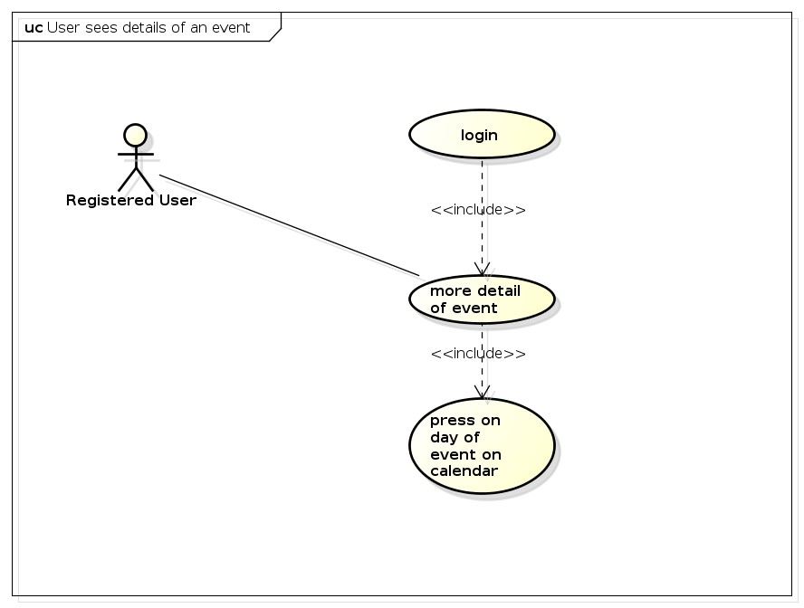

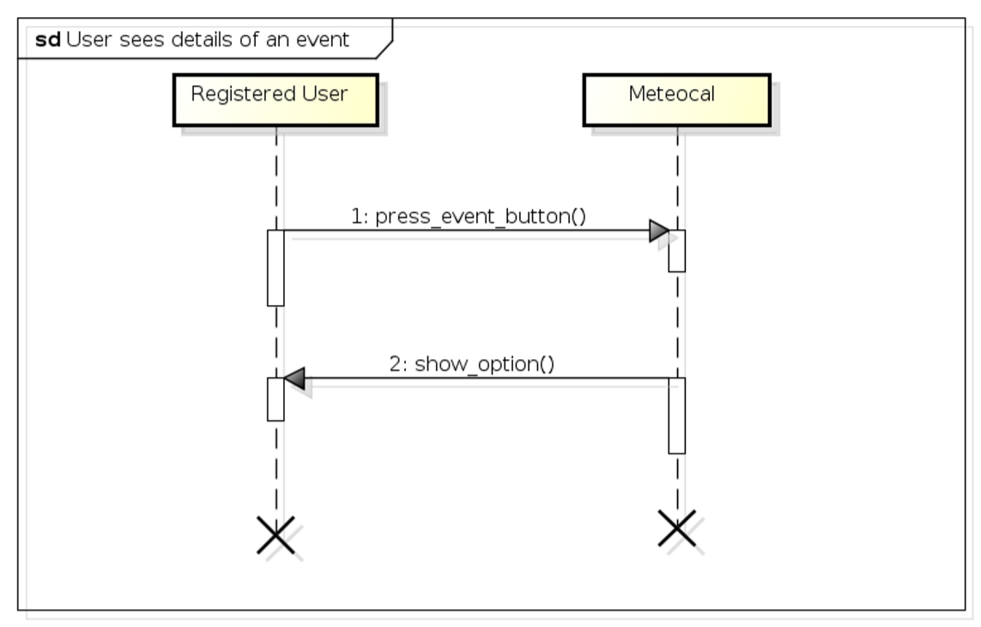

3.5.2 Class Diagrams

Here is presented the class diagram. This diagram will be updated during the developing process expecially adding all method.

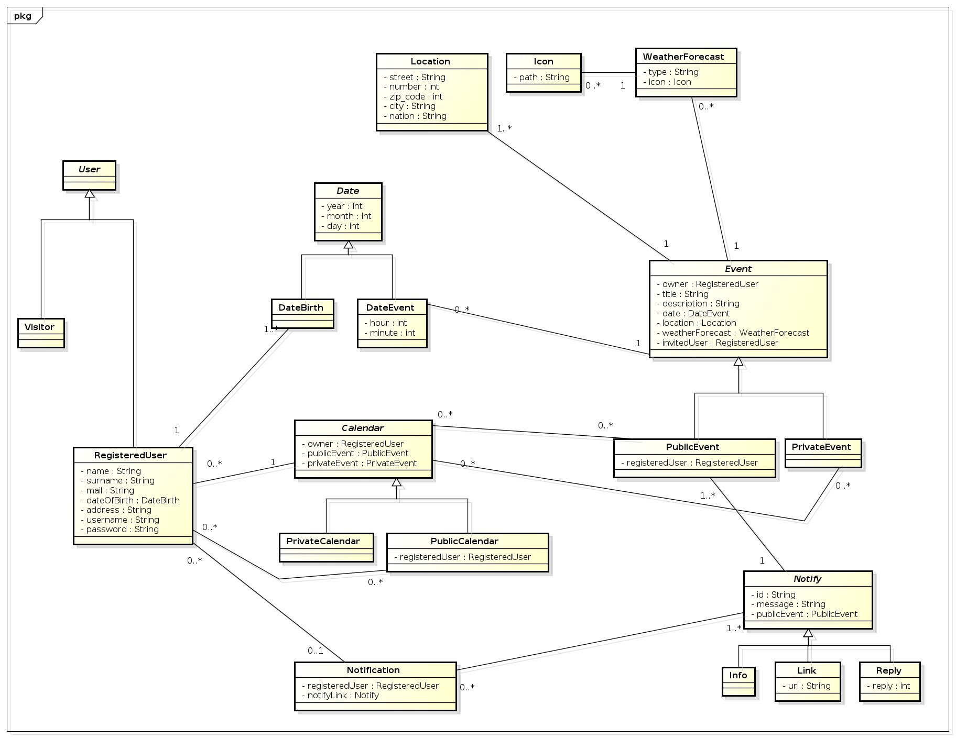

3.5.3 State Machine Diagrams

The follow state machine diagram would give a simplify vision of entair application.

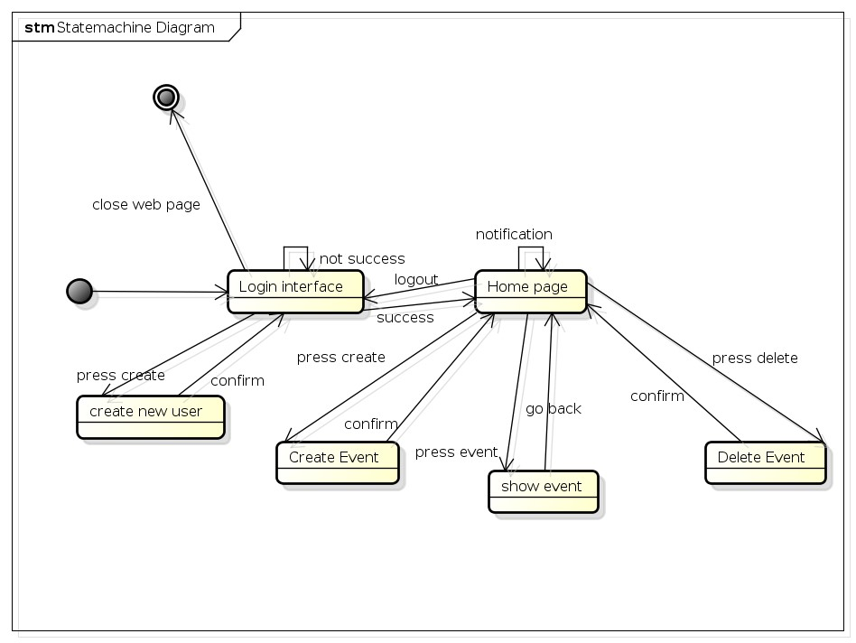

## Non Functional Requirements

3.6.1 Performance Requirements

Performance must be acceptable to garantee a good grade of usability. We assume the response time of the system is close to zero, so the performance are essentialy bounded by users internet connection.

3.6.2 Design Constraints

The application will be developed with Java EE so it will inherit all language’s constraints.

3.6.3 Software System Attributes

3.6.3.1 Availability The application will be accessible online anytime. To achieve this goal could be necessary to use a dedicated server but to guarantee more availability, all system could be hosted into cloud platform like Amazon EC2. This solution give more scalability to performance required by the system and could reduce the cost for dedicated server, mantaining an high level of performance especially in case of full load with a lot of connected users.

3.6.3.2 Maintainability The aplication does not provide any specific API, but the whole application code will be documented to well inform future developers of how application works and how it has been developed.

3.6.3.3 Portability The application could be used on any SO which supports JVM and DBMS.

3.6.4 Security

3.6.4.1 External Interface Side MeteoCal application implements a login authentication to protect the information of users. Password of user is saved using hashing mechanism but could not be enough. This system do not actually require anything about the strongness of the password so could be developed a system that require an 8 character password with number, letter and special character. Password also is static, user is not involved in password changing so system will ask to user to change frequently the password for example every 6 month or less. Another useful thing could be some advice to users about how to build a safe password. A more secure system will implement a login system with captcha test to prevent from botnet attack; could also be implemented a multifactor authentication system with a mixing of at least one of this technologies:

* Two-factor authentication whith a code sent by email or sms to the user
* Smart-cart authentication, a card with a chip used to authenticate the user through a smart card reader.
* Dyno tecnologies or one-time password, composed by a card static password list owned by user or a dyamic embedded password generator. The system ask for random code on that card or an entair code generated.
* Biometric: fingerprint, retina scan, voice analysis

3.6.4.2 Application Side On the application side could be implemented a filtering system to all form. Malicious user indeed can fill the form with sql code (sql injection) to have access to information who normally can not have access. Another important secure method is to implement the https connection instead of http to guarantee communication confidentiality and integrity and also mutual authentication. SSL is resistent to man in the middle attack(MITM) but need a server certificate signed by a Certification Authority(CA).

3.6.4.3 Server Side The server side architecture could be implemented dividing strongly the data from application. An idea of possible secure infrastructure is well represented by the following picture. Application Server is separated from database and from the web server. All zone are divided by firewall. Access to this zone is restricted and forbidden to not authorized user.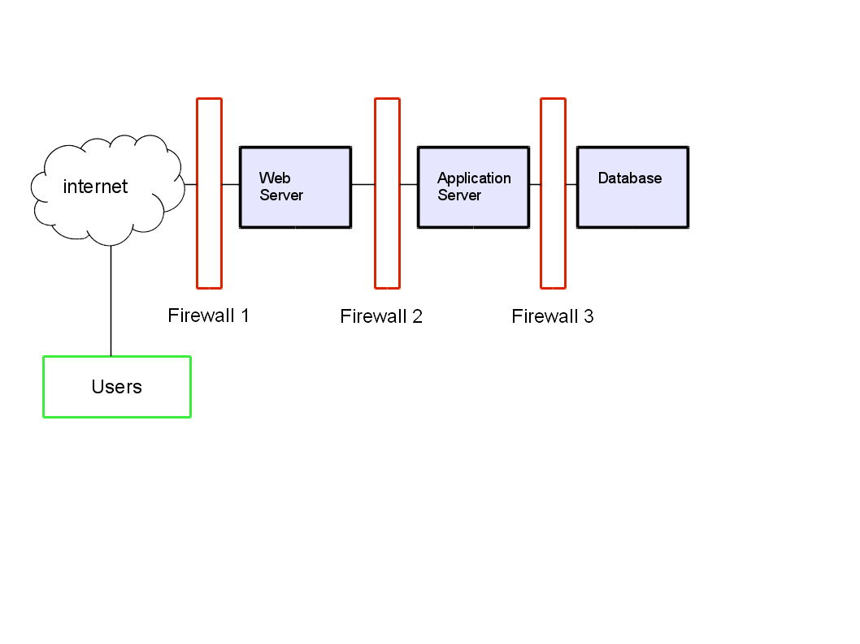

# Appendix

## Alloy

The complete alloy file (.als) could be find on our google code repository. The following alloy model presented is created using the class diagram. We try to divide the code in part dividing signature from fact, assert and predicates. In the last part there are the generated word.

4.1.1 Data Type

This is the definition of data type.

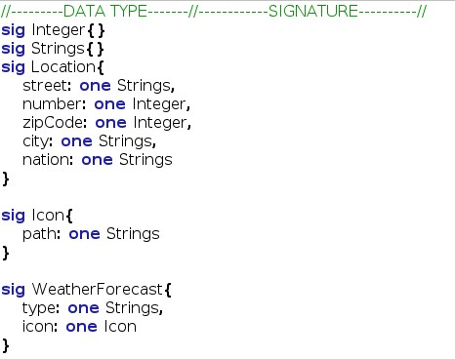

4.1.2 Abstract Entity

This is the definition of abstract entity.

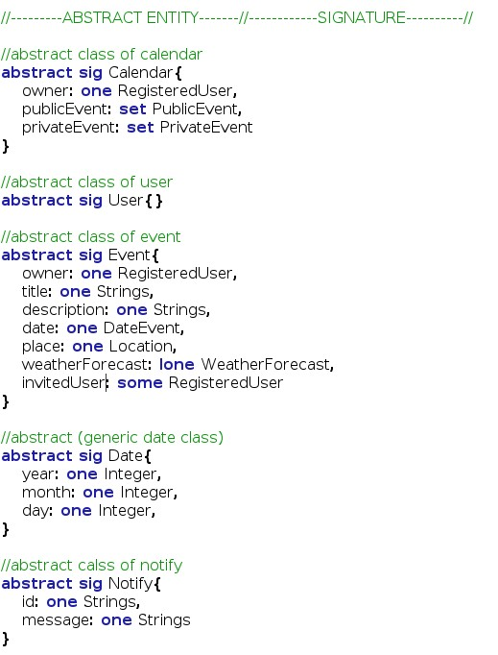

4.1.3 Abstrac Entity Implementation and Signature This is the implementation of some abstract entity and other signature.

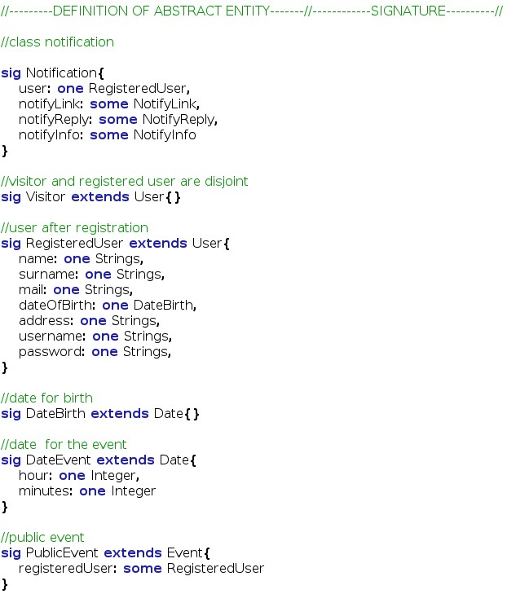

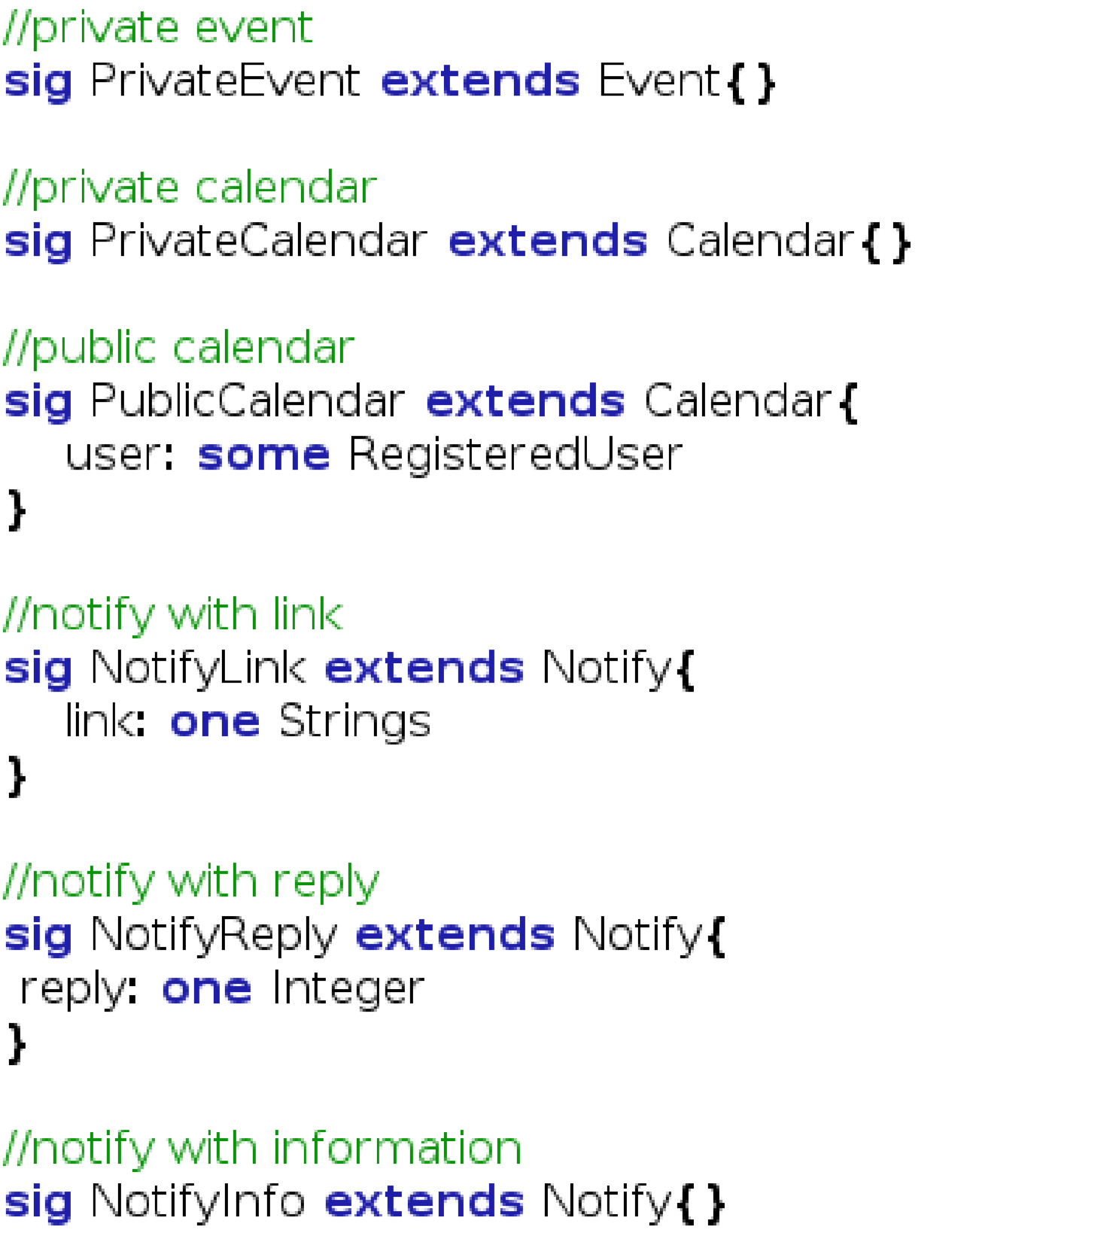

4.1.4 Fact

This

is

the

fact

part

that

defines

the

costraint

of

the

class.

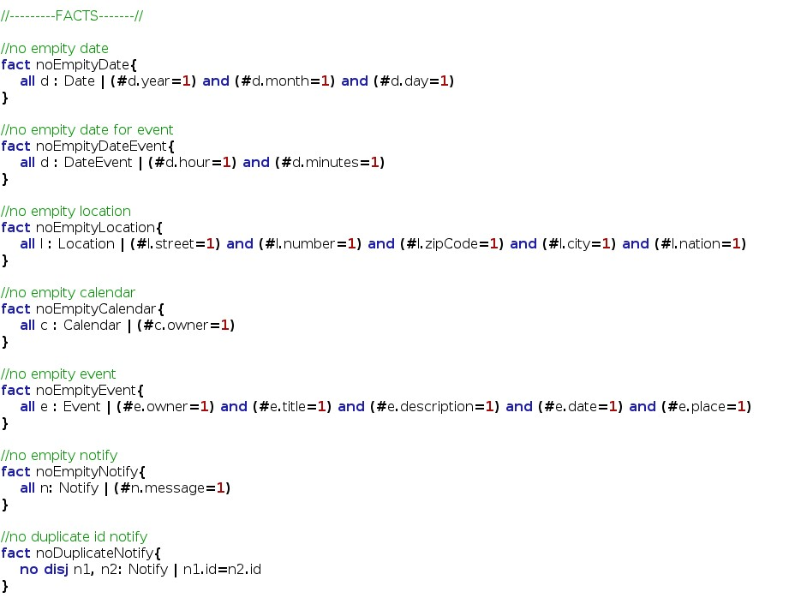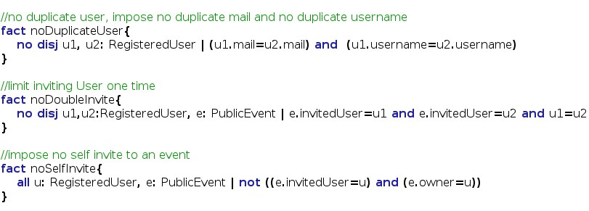

4.1.5 Assert

In

this

last

code

part

is

presented

the

assert

used

to

verify

the

model.

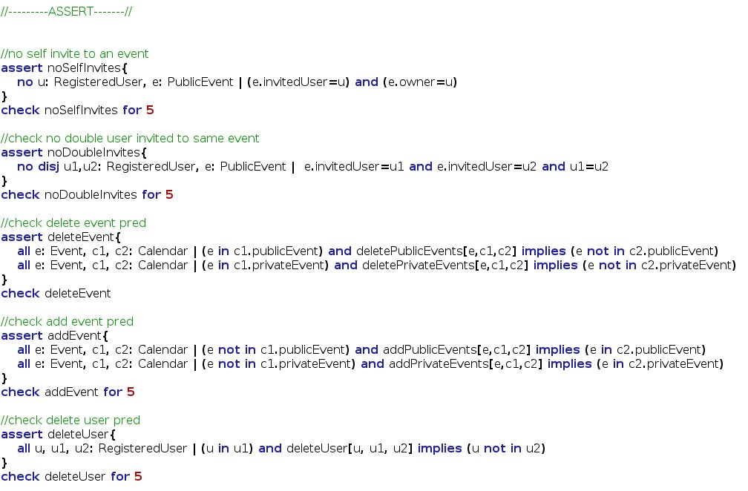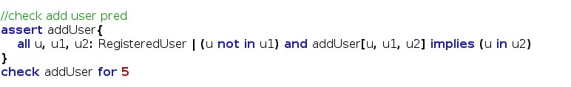

4.1.6 Predicates

This is the predicates used with the previous assert to verify the model.

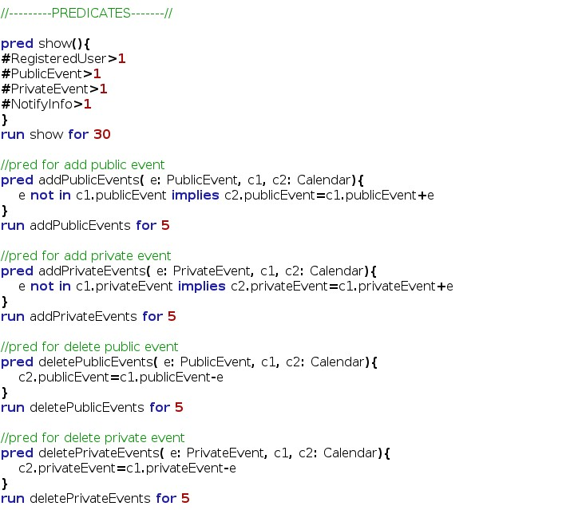

4.1.7 Result

This screenshot of the Alloy Analizer software that shows the consistence of the model in all part.

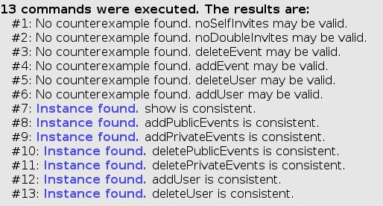

4.1.8 Generated world

Here is presented the generated world using the alloy verification software. First diagram is the predicate show() for 4 case. The second is the predicate show() for 8 case. For more case the model will be more and more complex and difficult to read. The third graph is generated from the deleteUser predicate. We decide to not attach all diagram because they are very complex and would not give other information or help anyone want to read this document.

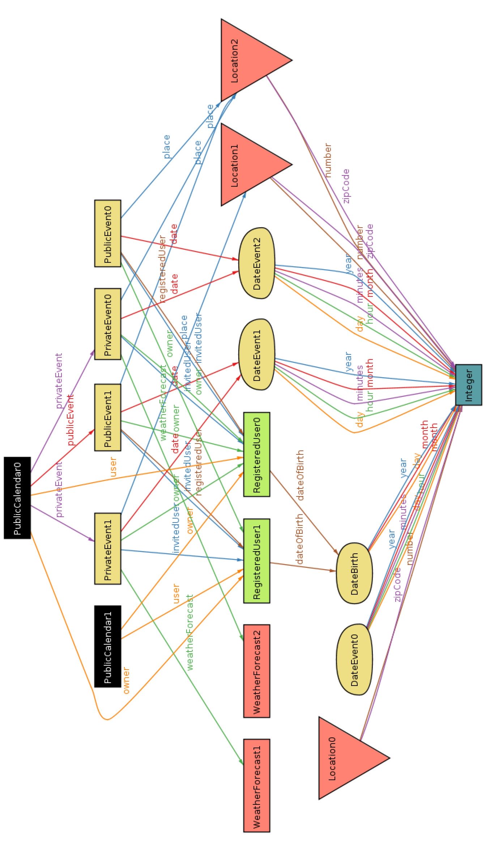

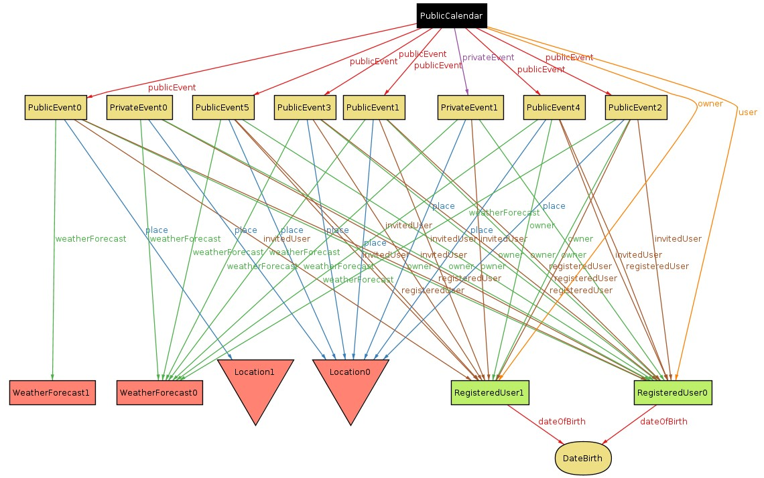

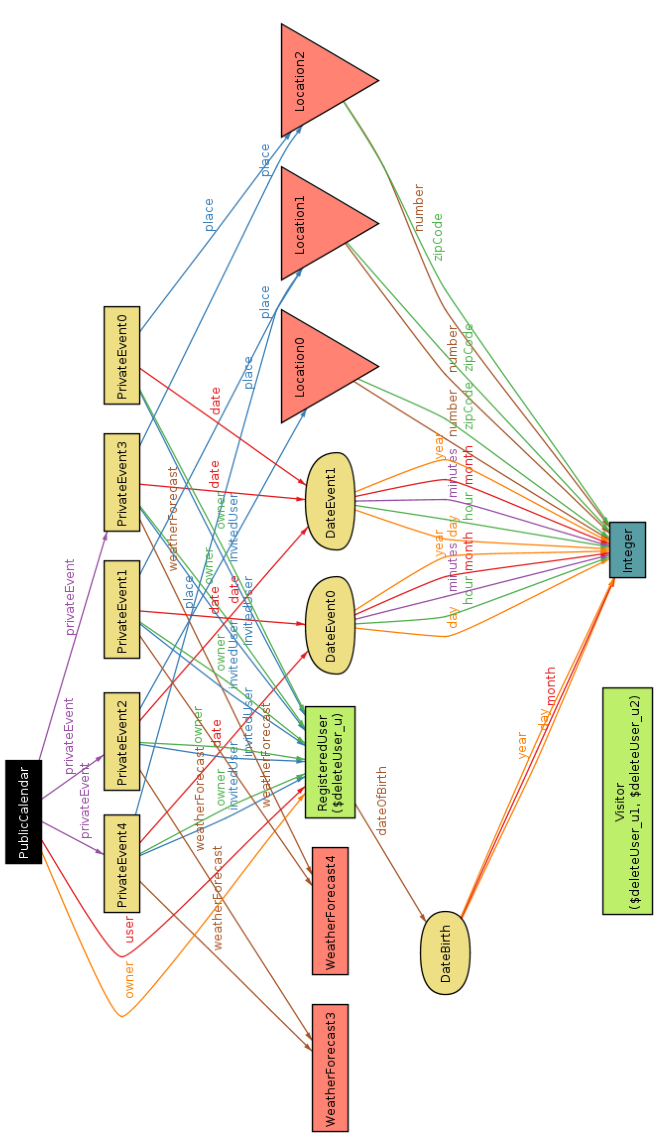

## Software and tool used

* Lyx [(http://www.lyx.org/)](http://www.lyx.org/): to redact and to format this document.
* Astah Professional [(http://astah.net/editions/professional)](http://astah.net/editions/professional): to create Use Cases Diagrams, Sequence Diagrams, Class Diagrams and State Machine Diagrams
* Alloy Analyzer[(http://alloy.mit.edu/alloy/)](http://alloy.mit.edu/alloy/): to prove the consistency of our model.
* Gimp[(http://www.gimp.org/)](http://www.gimp.org/): to modelling some image.
* Balsamiq Mockups[(http://balsamiq.com/products/mockups/)](http://balsamiq.com/products/mockups/): to create mockups.

## Hours of works

This is the time spent for redact this document:

* Federico Migliavacca: ~37 hours.
* Leonardo Orsello: ~37 hours.

# Revision

This is 2.0 version of RASD that contains update of the document after the entair development of the application. In the follow are listed the difference between the previous version:

## Changed Assumptions

* If there will not be a sunny day, the application will notify the owner this situation.
* If weather forecast is not available at the moment of creation of the event, this one will be created anyway and the weather field will be scheduled to be update the next ~~day untill weather forecast will be available~~ .
* [deleted] User can invites only after creation of the event, not during the creation of the event itself.
* [deleted] If an owner of one or more events delete his/her account all events will be deleted.
* There is not periodical update of weather forecast for event created. ~~Weather will be check only during creation process of the event~~ .
* [deleted] Weather is checked and updated just once three days before the event takes place.
* Notification of bad weather condition will be shown ~~just once~~ .

## Removed goal and functionality

* [G2] Allow user to change public or private nature of his/her calendar
* [G4] Allow user to delete his/her account from database.

## Modified Functional Requirements

* [G1] Allow a visitor to became a registered user and choose the public or private nature of his/her calendar.
  + [D1] Email address used for registration ~~must exist~~ .
* [deleted] [ex G2] Allow user to change public or private nature of his/her calendar
  + [R1] User must be already regitred to success login process.
  + [R2] Changing the global visibility of his/her calendar will affect the visibility of all related events.
* [deleted] [ex G4] Allow user to delete his/her account from database.
  + [R1] User must be already registred and logged in to application.
  + [R2] User must confirm deleting process.
  + [R3] The deleting process is not reversible, all user data will be lost.
* [G3] Allow user to create a new event in the calendar and choose the public or private nature.
  + [R3] User must complete mandatory fields ~~(date, time, location)~~ to complete the event creation process.
  + [deleted] [R4] Event creation process has some discretionary filelds.
  + [deleted] [D1] Location must be an existing city.
* [G6] Allow user to invite/delete other user to a specific event of his/her calendar.
  + [R5] To invite a user, the owner of the event, ~~must know the email of that specific user~~ .
* [G10] After login, application will notify only the creator user three days before an event takes place if the weather is not good.
  + [deleted] [R4] Notification will appear only once.
  + [deleted] [R6] If there will not be a sunny day in the next seven days after the event will take place, application will notify the owner.
  + [deleted] [R7] If weather forecast will not be available in the next seven days after the event will take place, application will notify the owner.
* [G11] After login, application will notify invited user one days before an event takes place if the weather is not good.
  + [R3] Application will notify ~~the owner~~ and invited users of the event only when they perform login.
  + [deleted] [R4] Notification will appear only once.

## Modified Scenarios and Use Cases

Updating some goal and functional requirements has bring some changes also to the scenario. In particular the Scenario 2, 3, 4, 6 and 7. For the use cases the modification are listed in the follow: • [deleted] “Edit Profile” Use Case

* [deleted] “Delete Profile” Use Case
* ~~User sees “event has been modifed" alert~~. This is substituted with: “User sees notification for modified event with another invitation” Use Case
* ~~User sees "other details" of an event~~. This is substituted with: “User sees details of an event” Use Case.

## Modified Diagrams

The diagrams of Use Case quoted above have been modified. An update has also been applied to the State Machine Diagram. The Class Diagram has not been modified since there aren’t structural error but some class were already natively implemented in Java. Some little modification could be necessary for Mock-up but screenshot of real application are available in the user manual.